National Textile University, Faisalabad


Department of Computer Science
Name | Ghulam Habib
Class | BSSE 3rd
Section | A
Registration No | 24-NTU-CS-FL-1154
Assignment | Lab-1
Course Code | DS-2077
Course Name | Data Structures
Submitted To | Sir Basit
Submission Date | 20-October -2025

DATA STRUCTURES
Lab Plan – 1

Exercise-1: Following is the declaration of Node class and its member functions. Write the complete definitions of these member functions.

Code :

#include <iostream>

#ifndef H_Node

#define H_Node

using namespace std;

class node

{

private:

int data;

node *next;

node *prev;

public:

node()

{

data = 0;

next = NULL;

prev = nullptr;

}

void setData(int);

void setNext(node*);

void setPrev(node*);

int getData();

node * getNext();

node * getPrev();

};

// implementing the node

void node::setData(int data)

{

this->data=data;

}

void node::setNext(node * next)

{

this->next=next;

}

void node::setPrev(node* prev)

{

this->prev=prev;

}

int node::getData()

{

return data;

}

node * node::getNext()

{

return next;

}

node * node::getPrev()

{

return prev;

}

#endif

Screenshot : 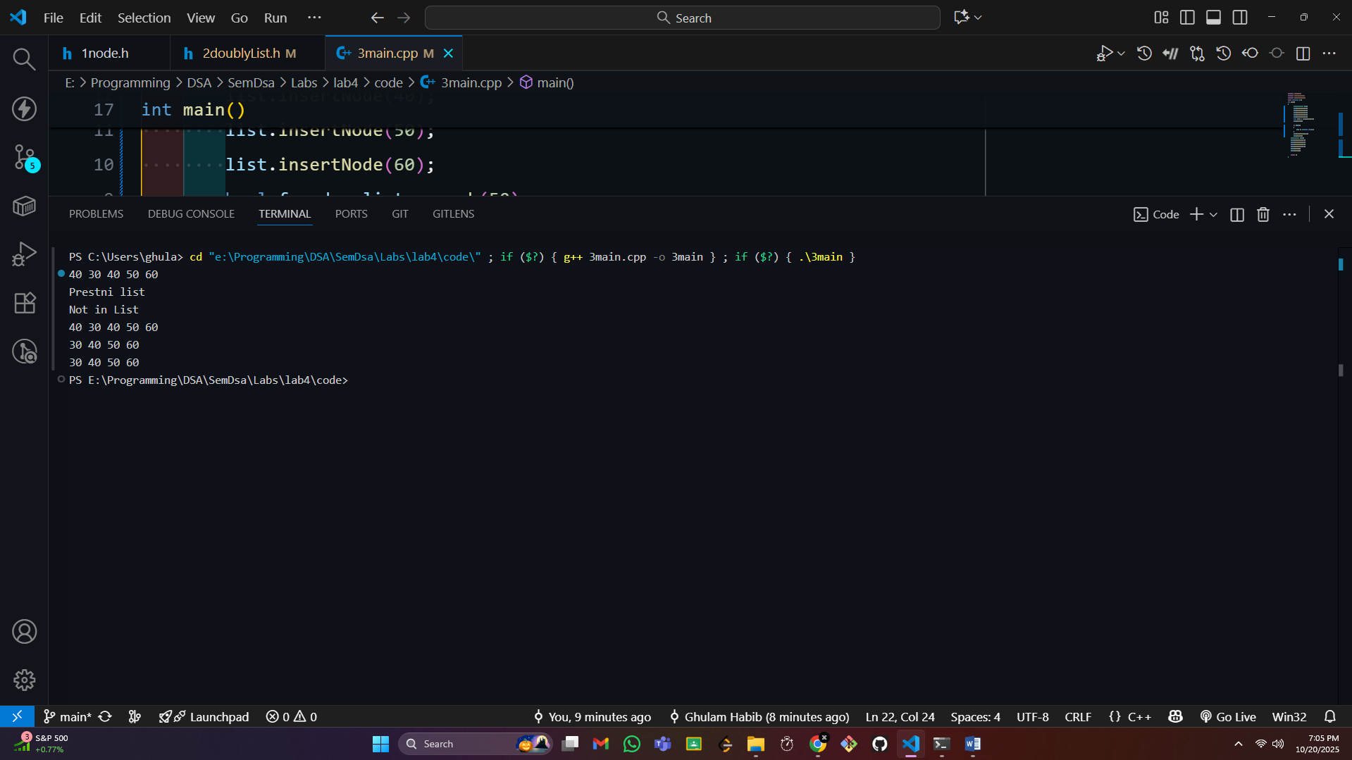

Exercise-2:

Following is the declaration of DoublyList class and its member functions. Write the complete definitions of these member functions.

Code :

#include <iostream>

#include "1node.h"

#ifndef H_DoublyList

#define H_DoublyList

using namespace std;

class doublyLinkList

{

protected:

node *first;

node *last;

int count;

public:

doublyLinkList();

void insertNode(int);

void deleteNode(int);

bool search(int);

void print();

};

void doublyLinkList::deleteNode(int data)

{

node * prev;

bool nodyFound = false;

bool found = search(data);

if(!found)

{

cout<<"Not in List\n";

return;

}

if (first == NULL)

{

cout << "Empty list\n";

return;

}

node * curr=first;

while(curr!=NULL && curr->getData()!=data)

{

curr=curr->getNext();

}

if(curr==first)

{

first=first->getNext();

if(first!=NULL)

{

first->setPrev(NULL);

}

}

else{

prev=curr->getPrev();

prev->setNext(curr->getNext());

if(curr->getNext()!=NULL)

{

curr->getNext()->setPrev(prev);

}

}

if(curr==last)

{

last=curr->getPrev();

}

delete curr;

count--;

}

bool doublyLinkList::search(int data)

{

bool found = false;

if (first == NULL)

{

return false;

}

if (first->getData() == data)

{

return true;

}

else

{

node *temp = first;

found = false;

while (temp != NULL && !found)

{

if (temp->getData() == data)

{

found = true;

break;

}

else

{

temp = temp->getNext();

}

}

if (found)

{

found = temp->getData() == data;

}

return found;

}

}

doublyLinkList::doublyLinkList()

{

this->first = NULL;

this->last = NULL;

this->count = 0;

}

void doublyLinkList::insertNode(int data)

{

node *newNode = new node();

newNode->setData(data);

if (first == NULL)

{

this->first = newNode;

this->last = newNode;

count++;

}

else

{

last->setNext(newNode);

newNode->setPrev(last);

last = newNode;

count++;

}

}

void doublyLinkList::print()

{

node *temp = first;

while (temp != NULL)

{

cout << temp->getData() << " ";

temp = temp->getNext();

}

cout << endl;

}

#endif

Screenshot :


Exercise-3:

Write appropriate main() function to test the working of the Doubly-linked list.

Code:

#include <iostream>

#include "2doublyList.h"

#include "circularList.h"

using namespace std;

int main()

{

doublyLinkList list;

list.insertNode(40);

list.insertNode(30);

list.insertNode(40);

list.insertNode(50);

list.insertNode(60);

bool found = list.search(50);

list.print();

if (found)

{

cout << "Prestni list\n";

}

list.deleteNode(480);

list.print();

circularList cList;

cList.insertNode(30);

cList.insertNode(40);

cList.insertNode(50);

cList.insertNode(60);

cList.print();

cList.print();

return 0;

}

Screenshot :



Exercise-4: Implement the circular link list and the josephs problem using circular link list

Code :

#include <iostream>

using namespace std;

#ifndef H_circularList

#define H_circularList

#include "2doublyList.h"

#include "1node.h"

class circularList : public doublyLinkList

{

public:

circularList() : doublyLinkList()

{

this->first = nullptr;

this->last = nullptr;

}

void insertNode(int);

void print();

int josephus(int);

};

void circularList::print()

{

if (first == NULL)

{

cout << "List is empty\n";

return;

}

node *temp = first;

do

{

cout << temp->getData() << " ";

temp = temp->getNext();

} while (temp != first);

cout << endl;

}

void circularList::insertNode(int data)

{

node *newNode = new node();

newNode->setData(data);

if (this->first == NULL)

{

first = newNode;

last = newNode;

last->setNext(first);

last->setPrev(first);

first->setPrev(last);

}

else

{

newNode->setNext(first);

newNode->setPrev(last);

first->setPrev(newNode);

last->setNext(newNode);

last = newNode;

}

}

int circularList::josephus(int k)

{

if (first == NULL || k <= 0)

{

return -1;

}

node *curr = first;

node *prev = last;

while (curr->getNext() != curr)

{

for (int i = 1; i < k; i++)

{

prev = curr;

curr = curr->getNext();

}

prev->setNext(curr->getNext());

curr->getNext()->setPrev(prev);

if (curr == first)

first = curr->getNext();

if (curr == last)

last = prev;

delete curr;

curr = prev->getNext();

}

return curr->getData();

}

#endif

ScreenShot :
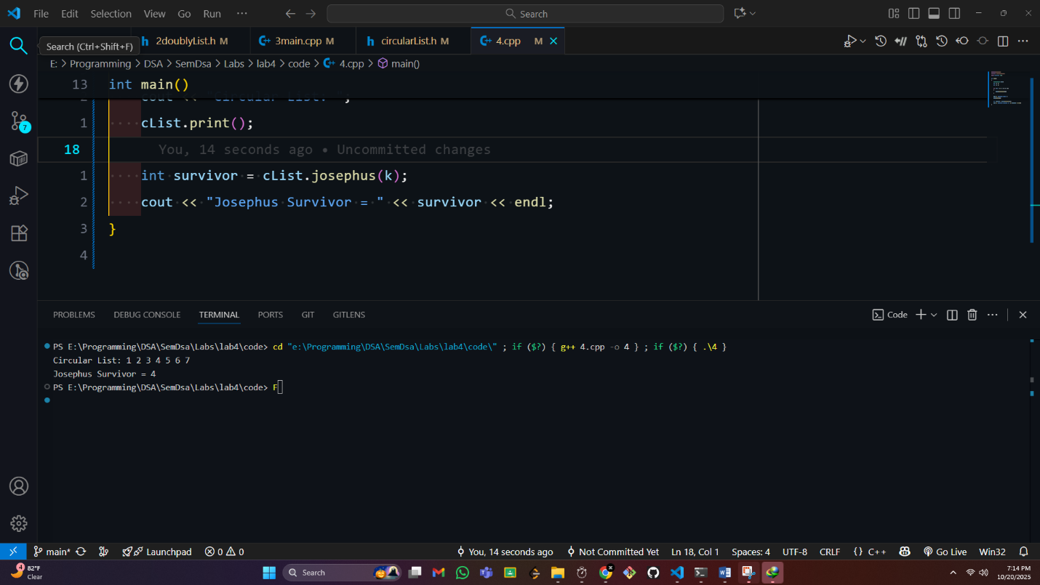

===========End==============

